**Practical No. 03**

**Aim: Study and implementation of Software as a Service**

**Theory:** SaaS is also known as "**On-Demand Software**". It is a software distribution model in which services are hosted by a cloud service provider. These services are available to end-users over the internet so, the end-users do not need to install any software on their devices to access these services.

There are the following services provided by SaaS providers -

**Business Services** - SaaS Provider provides various business services to start-up the business. The SaaS business services include **ERP** (Enterprise Resource Planning), **CRM** (Customer Relationship Management), **billing**, and **sales**.

**Document Management** - SaaS document management is a software application offered by a third party (SaaS providers) to create, manage, and track electronic documents.**Example:** Slack, Samepage, Box, and Zoho Forms.

**Social Networks** - As we all know, social networking sites are used by the general public, so social networking service providers use SaaS for their convenience and handle the general public's information.

**Mail Services** - To handle the unpredictable number of users and load on e-mail services, many e-mail providers offering their services using SaaS.

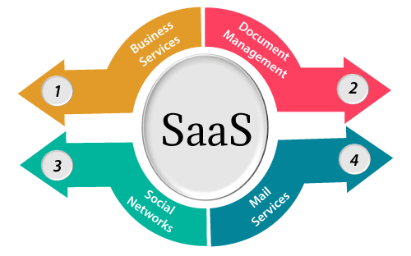

**Methods and Steps:**

1. Using FOSS Server

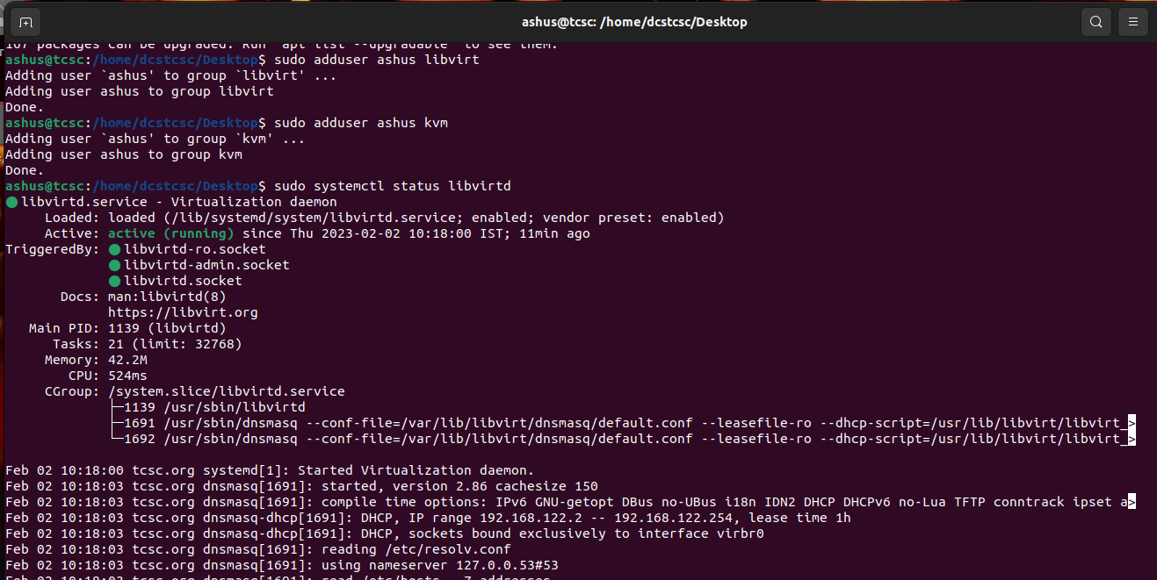

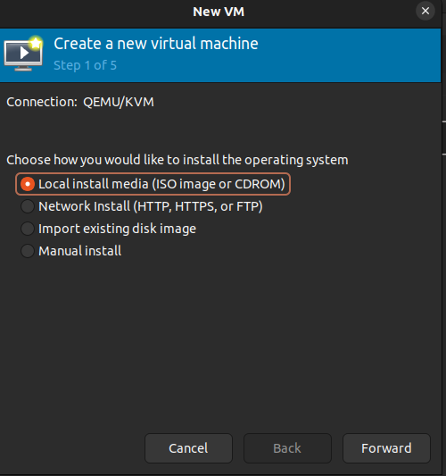

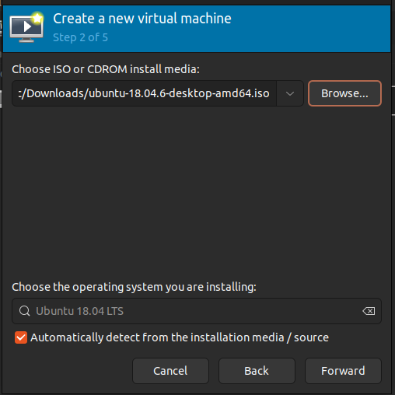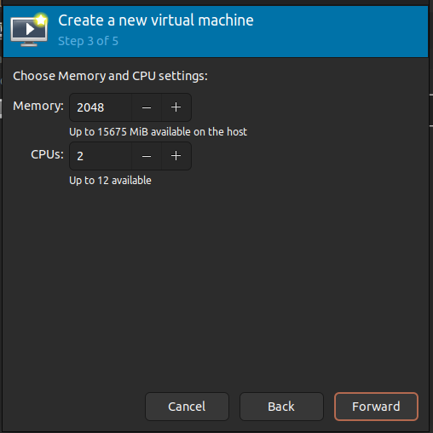

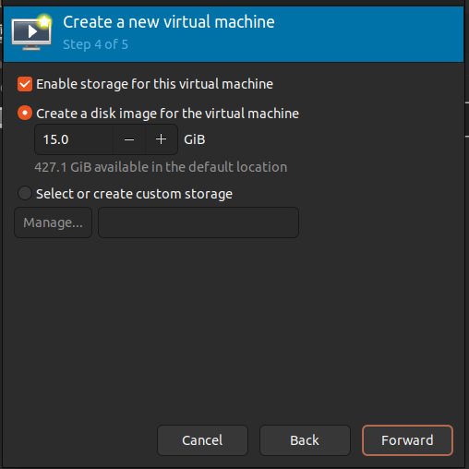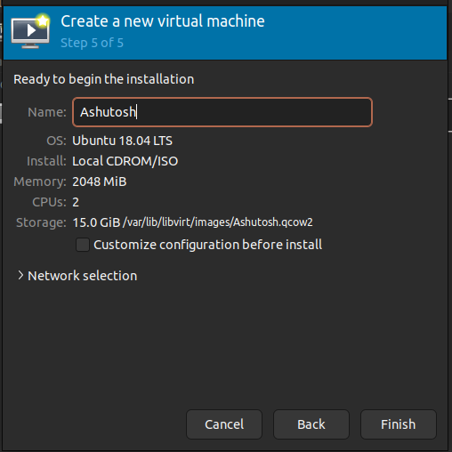

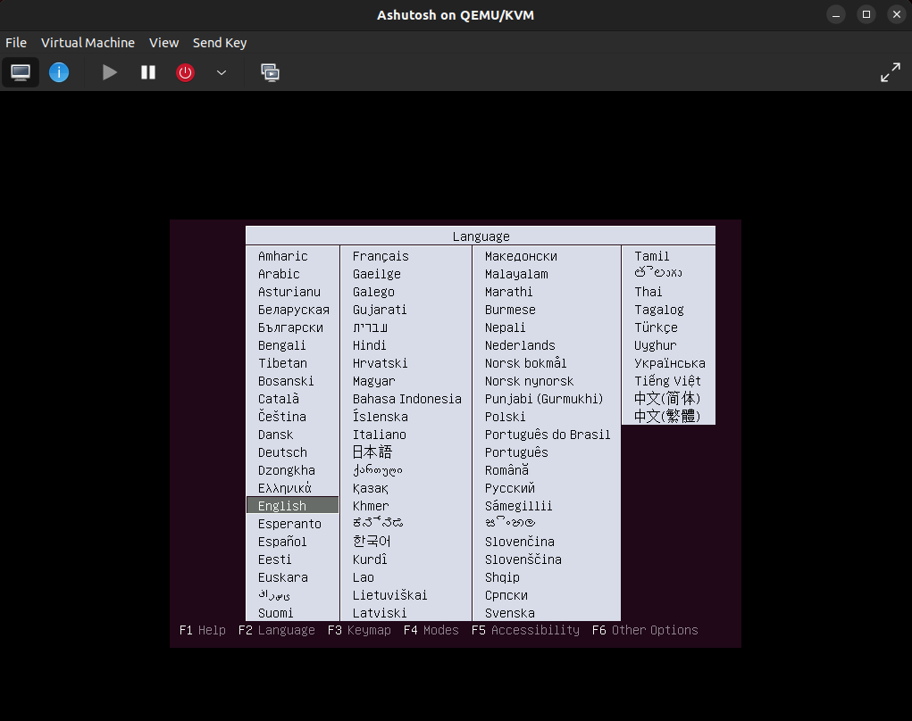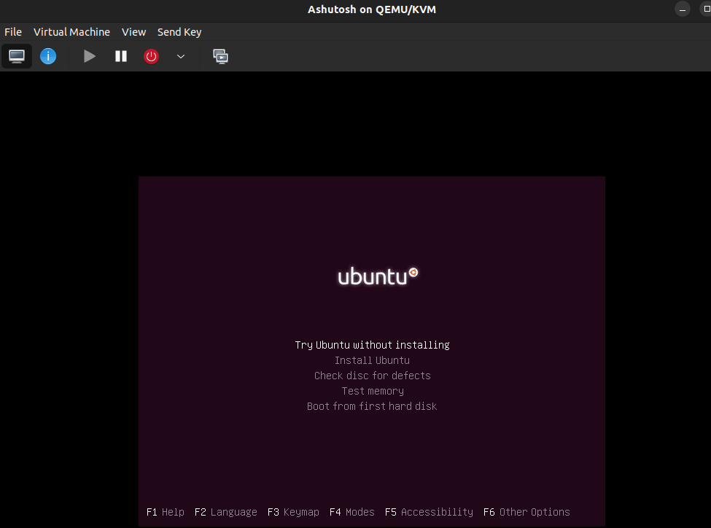

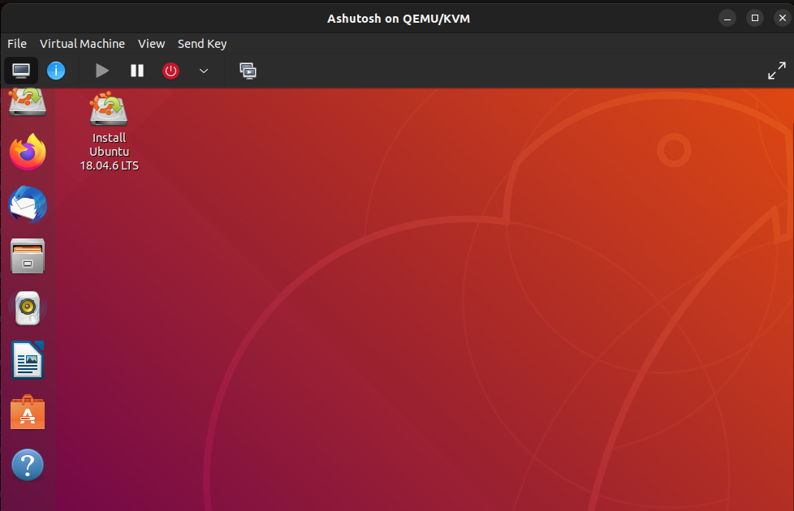











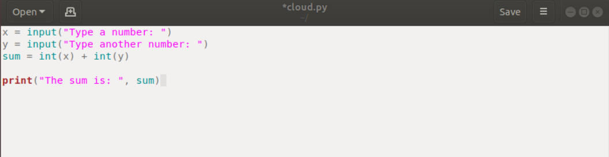

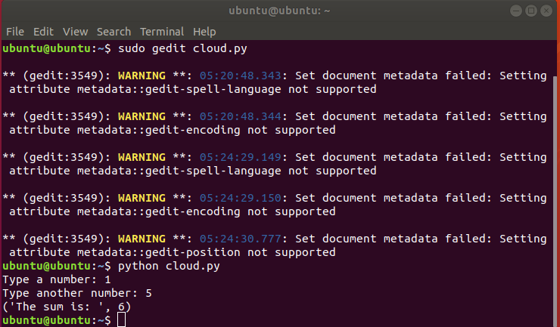

. B.GCP/AWS/IBM/AZure/...

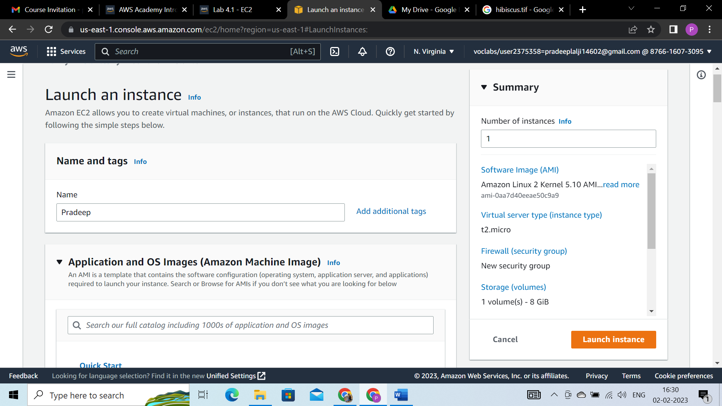

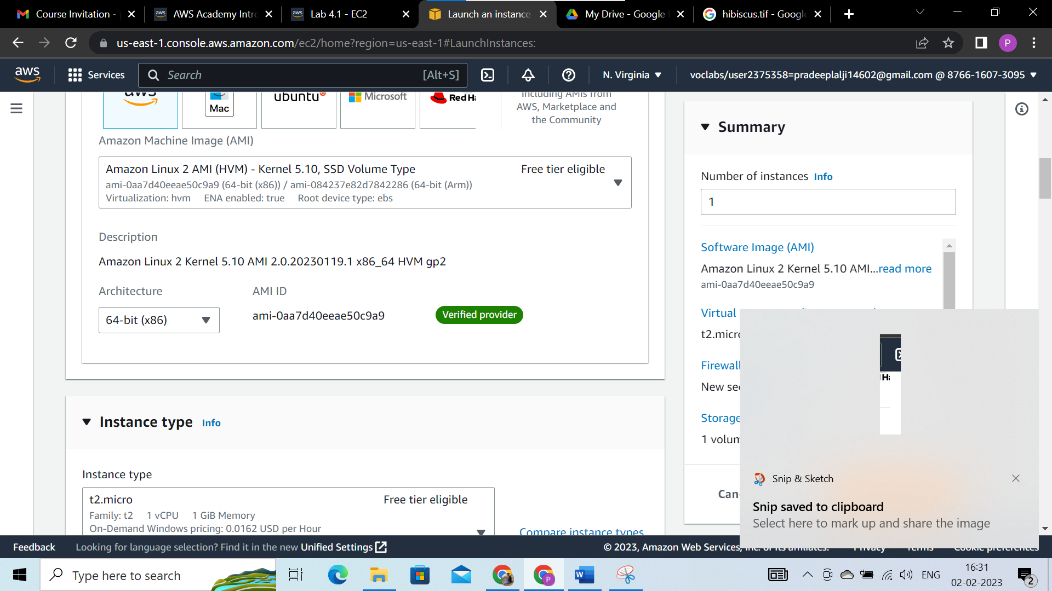

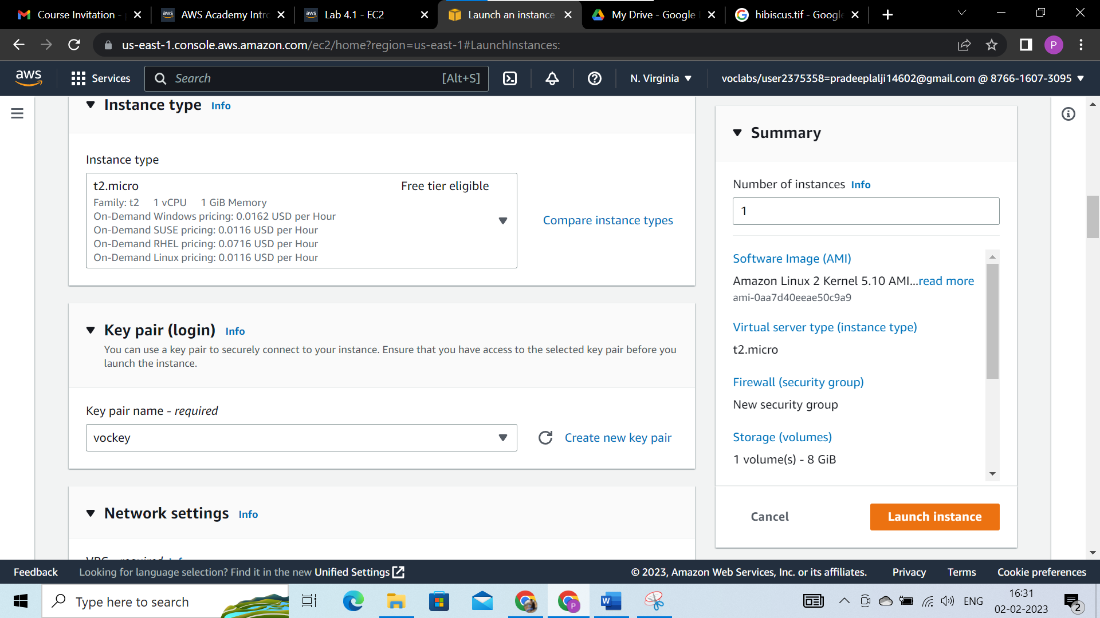

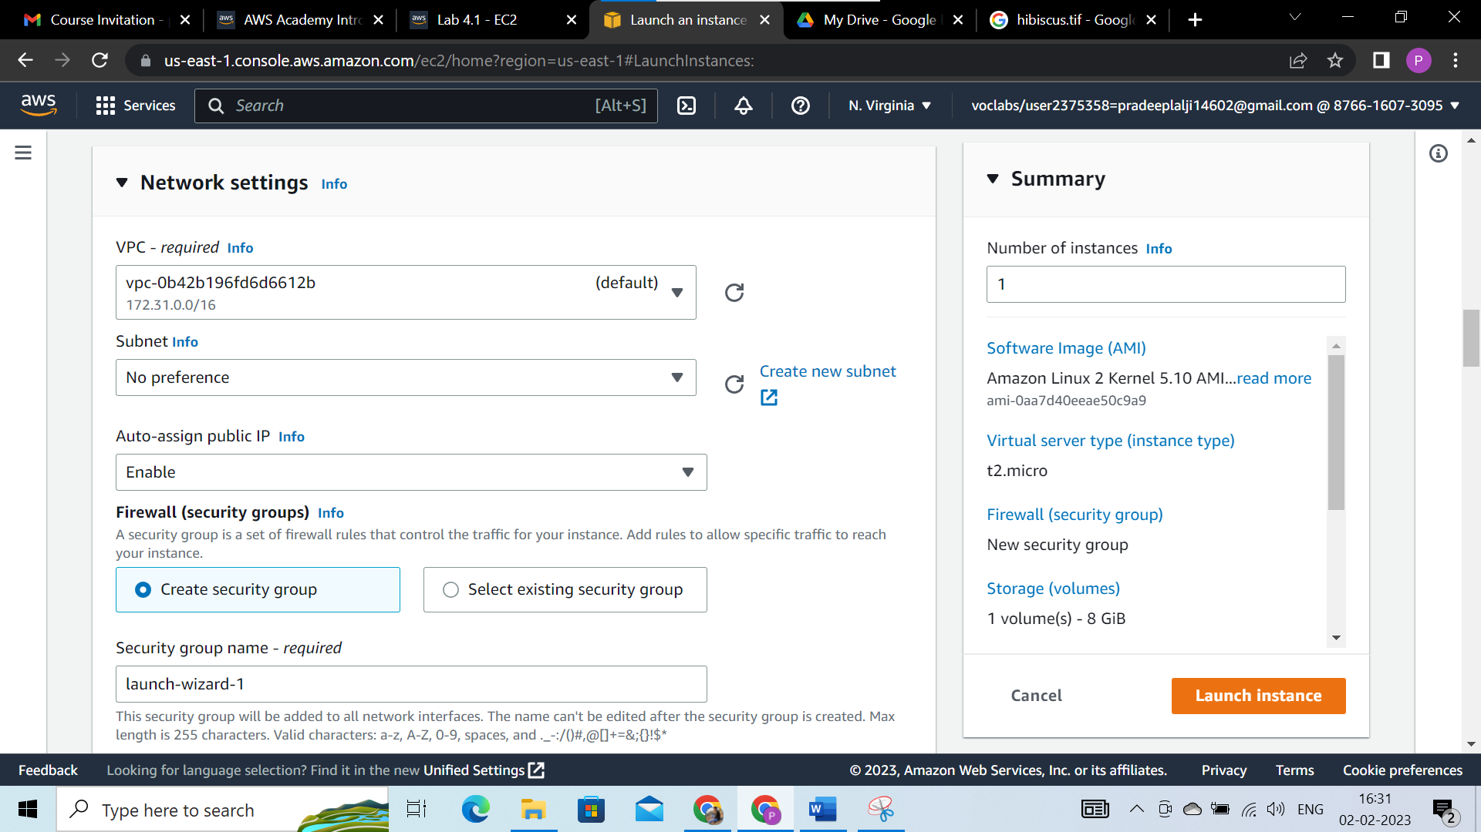

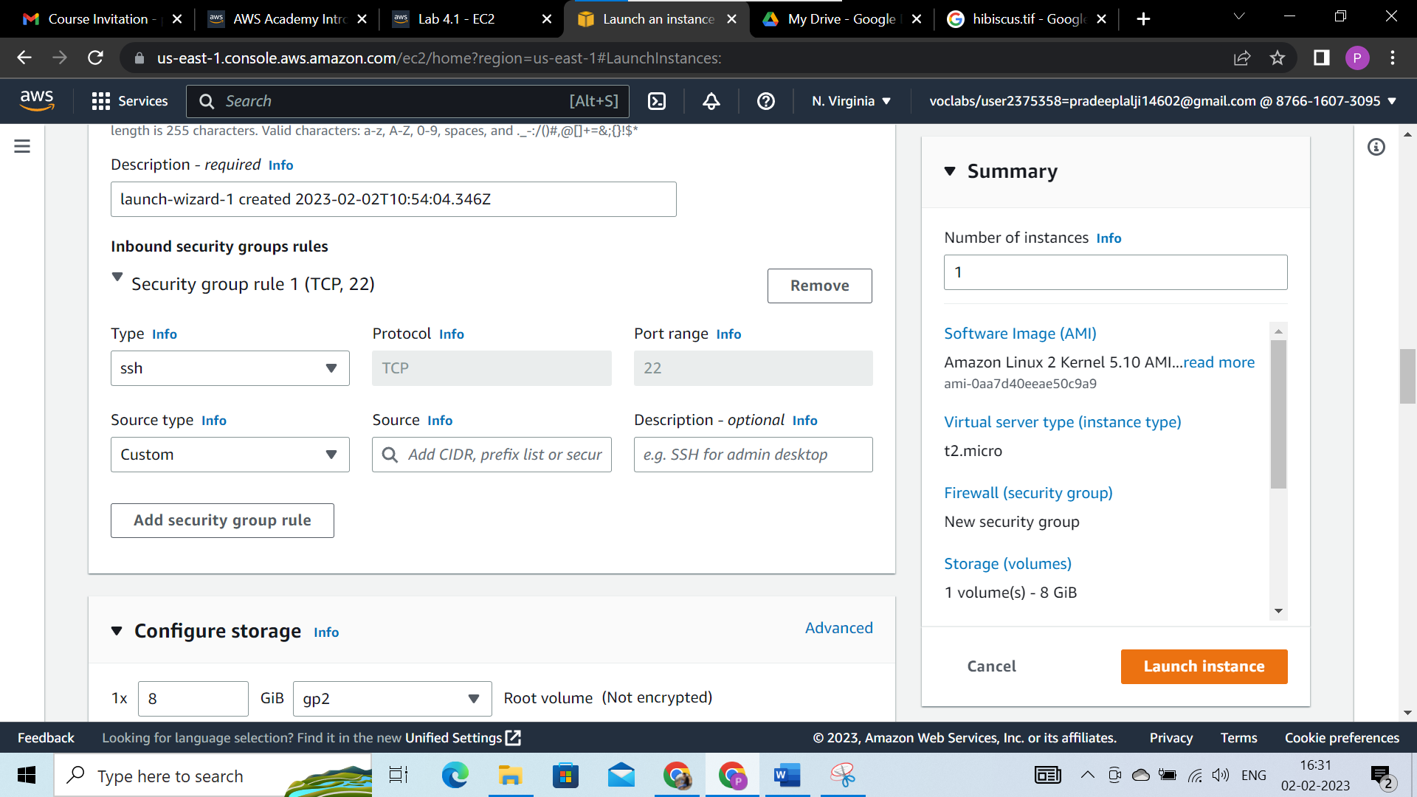

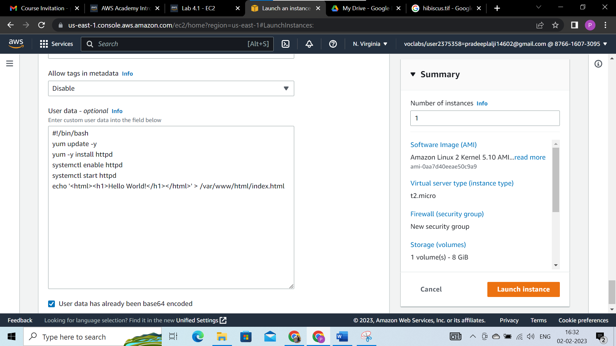

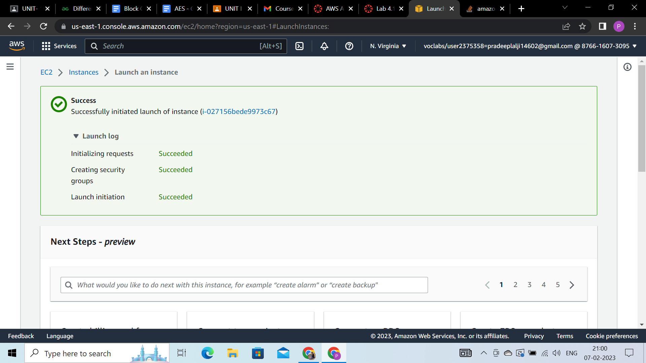

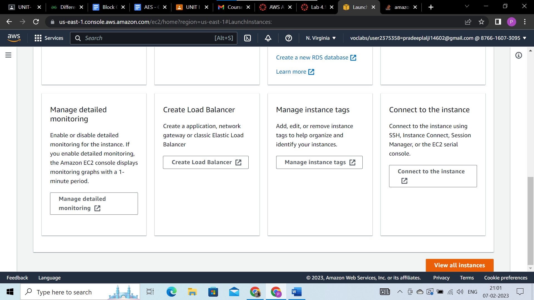

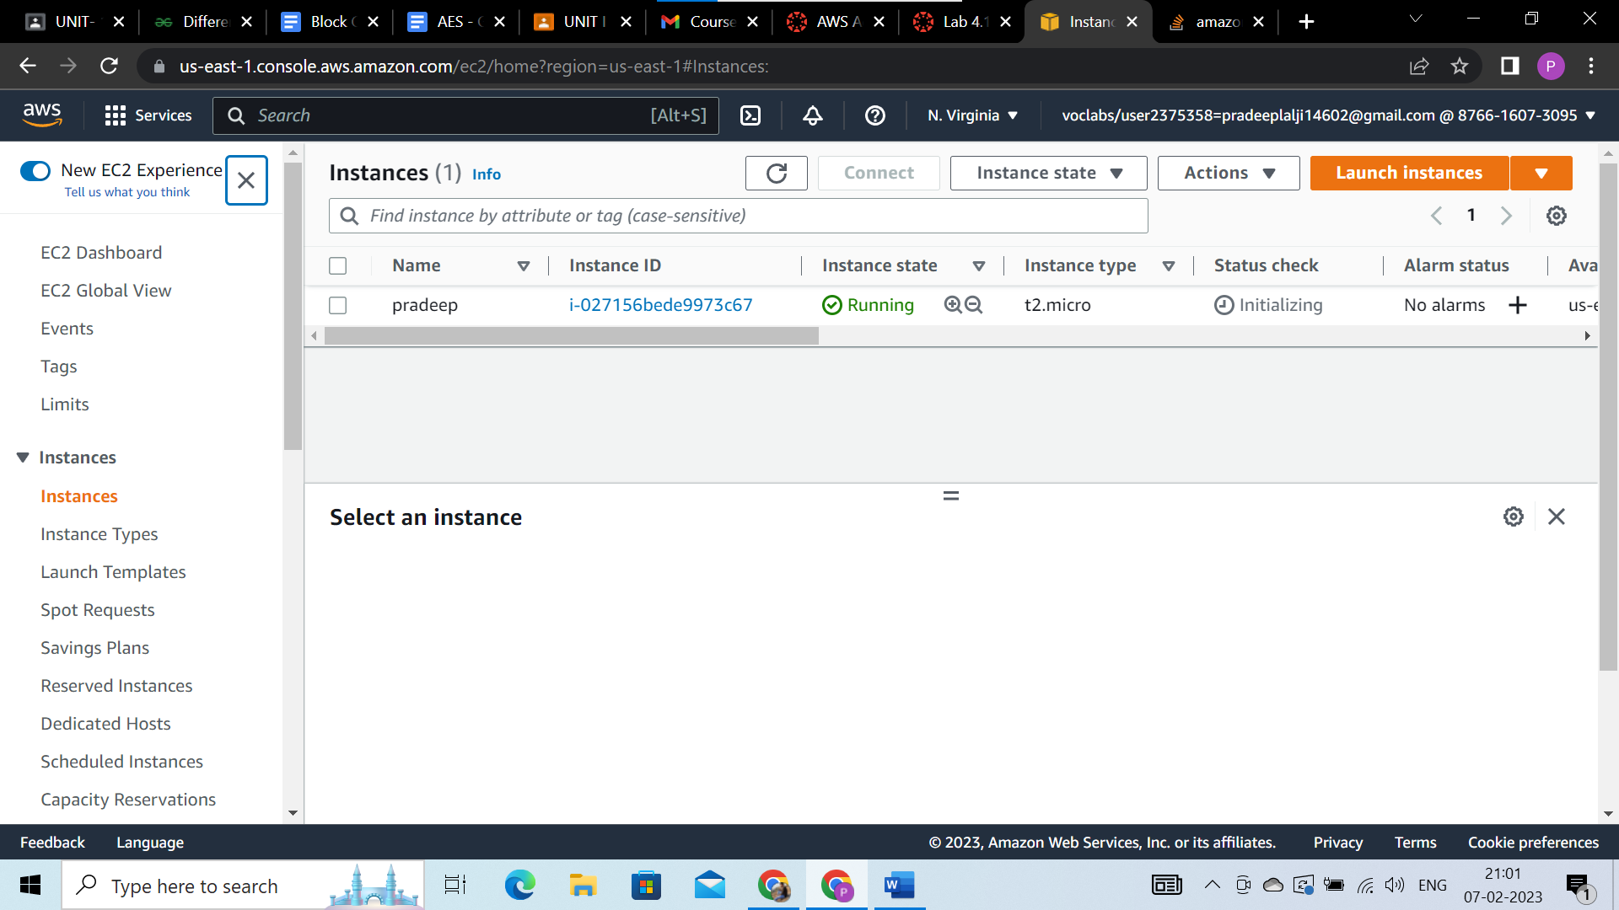

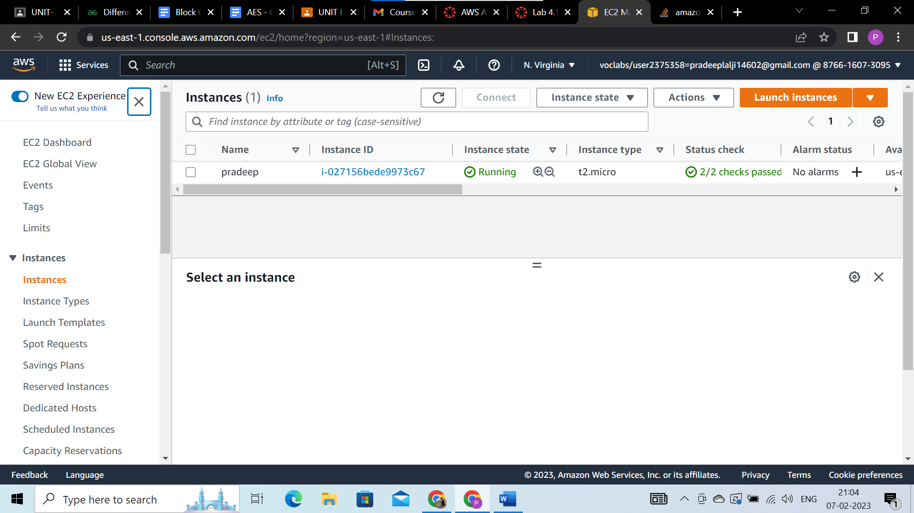

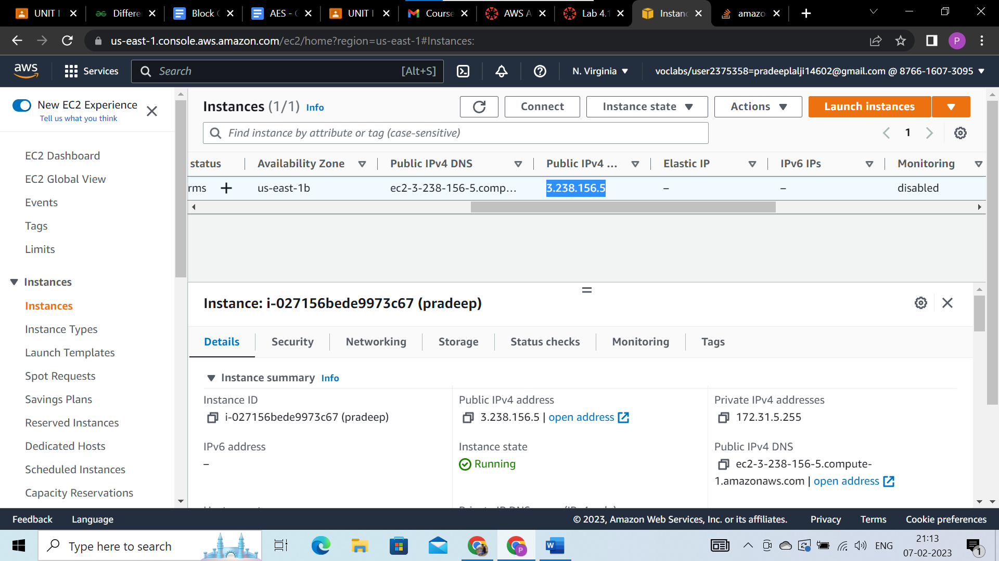

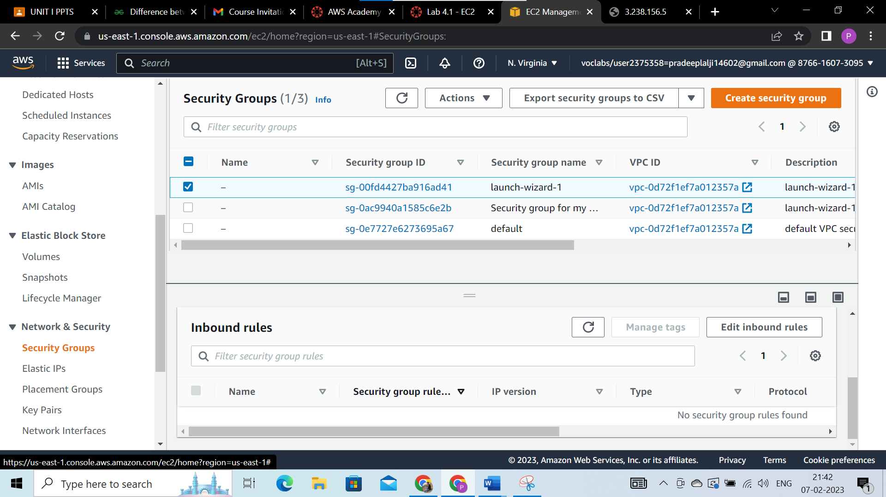

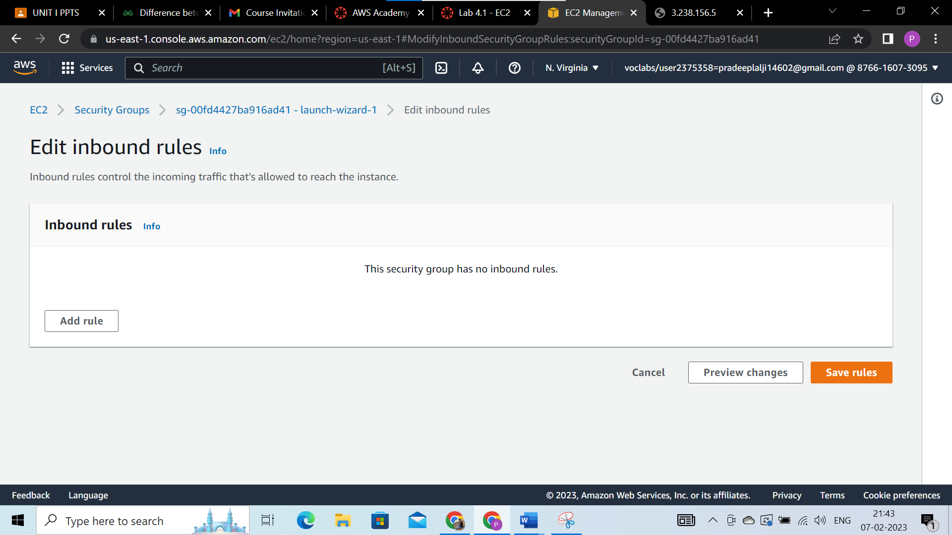

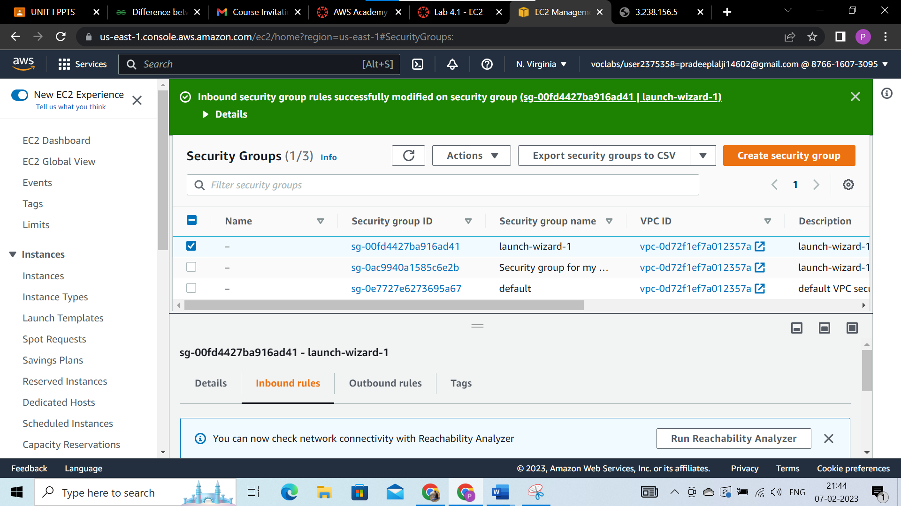

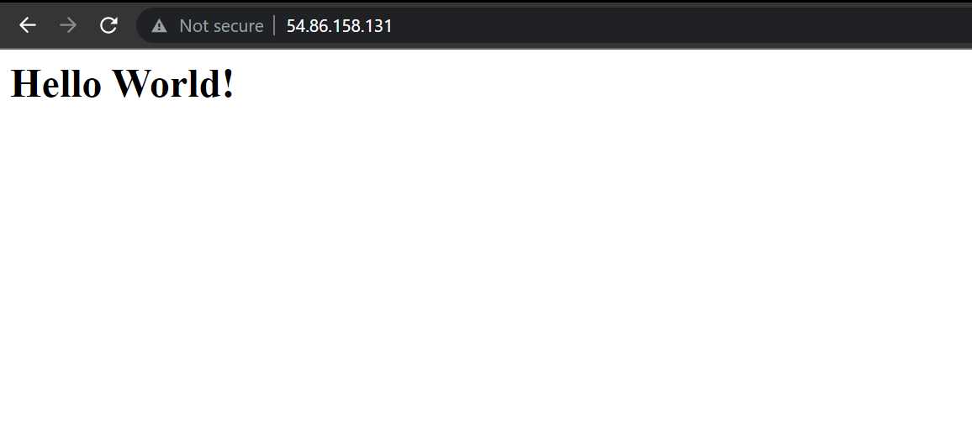

## CONCLUSION :

## Advantages of SaaS cloud computing layer :**SaaS is easy to buy,** **One to Many** ,**Less hardware required for SaaS,** **Low maintenance required for SaaS,** **No special software or hardware versions required.**

## Disadvantages of SaaS cloud computing layer :**Security,** **Latency issue,** **Total Dependency on Internet,** **Switching between SaaS vendors is difficult.**